**External Traffic allow from load balancer only not from direct hits**

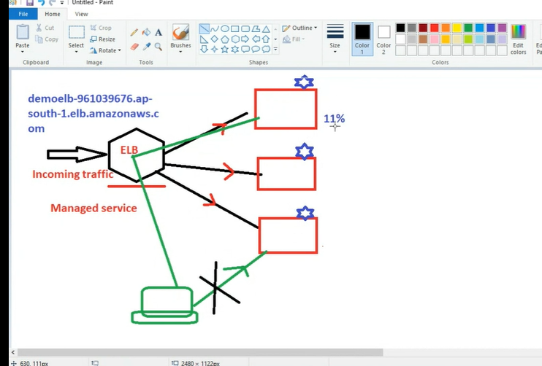

Sg ka khel hai sara

Pahela sg bano for ELB –

Apna elb ssh nahi magta as it is managed service we can not login into it-

1. Sg used in load balancer should contain http and https only no need of ssh – make different sg for LB

Dusra sg bano for ec2 here only elb should send traffic -

Here two sg are there

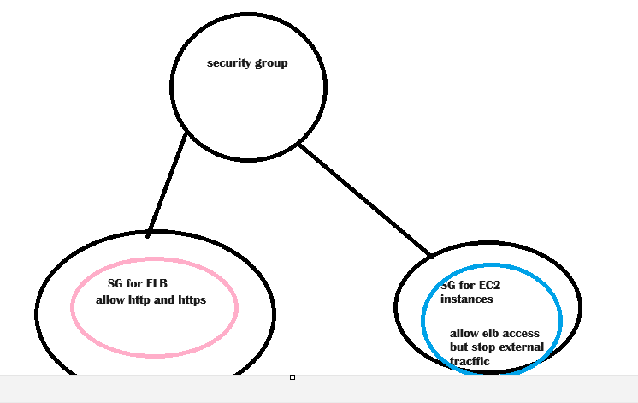

We need to use custom setting and select sg_for_elb_only

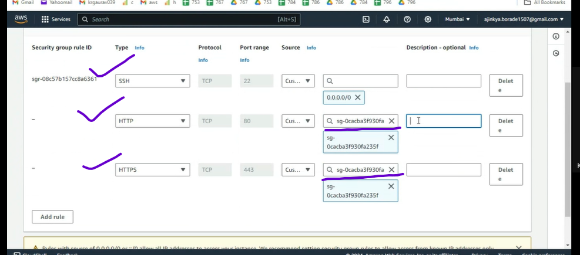

1. One more change make ssh for my ip only ----

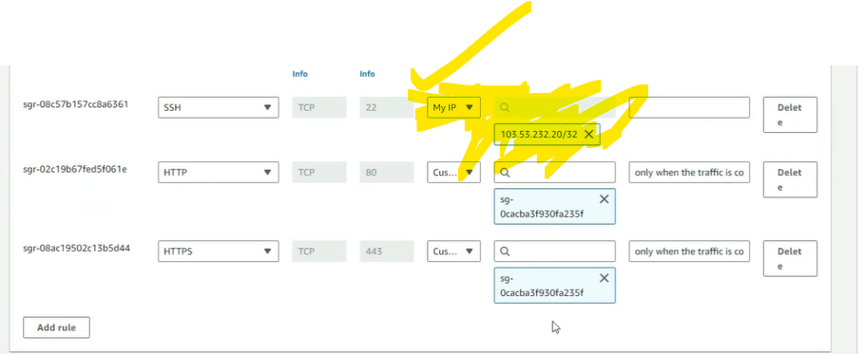

Testing –

check ip address working on web ---- no

Load balancer DNS -------------- yes

Project –3

Aim – access ec2 server when key lost and putty connect not working

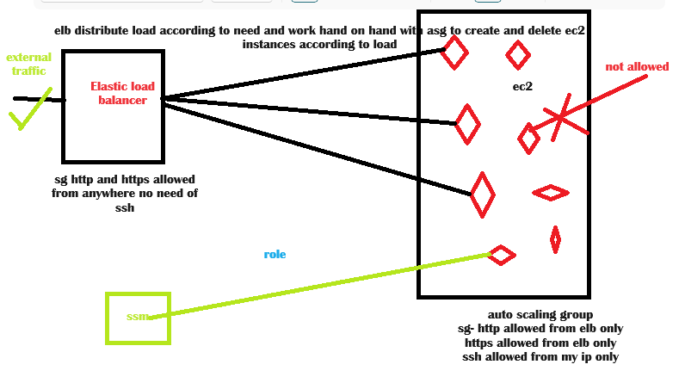

Steps to do this –

1. Create sg of elb where only http and https open
2. Create sg of asg where https allowed from custom and https allowed from custom i.e allow from elb only.
3. Create template for asg where give sg of asg
4. Create load balancer
5. Create asg
6. Now the main challenge here is we can not access ec2 instances from putty, web browser, ports, key pair all but if we allow system manager to access ec2 we can easily access ec2 instances just need to add role to ec2 .we can connect role to running instance.

Testing results –

check ip address working on web ---- no

Load balancer DNS -------------- yes

Able to login ec2 -

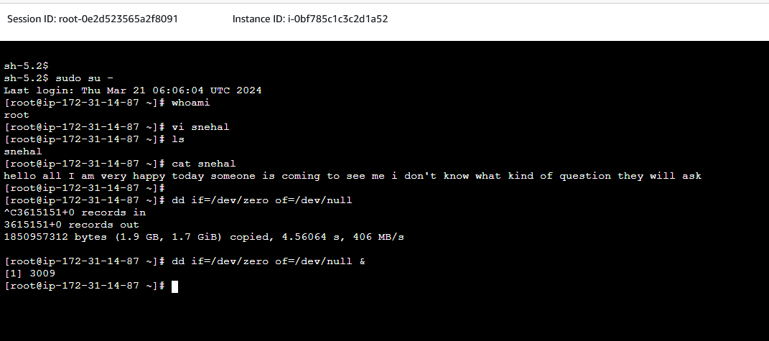

Load balancer testing for different ec2 instances -

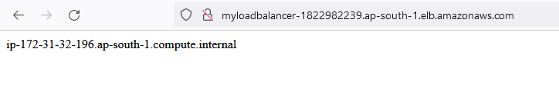

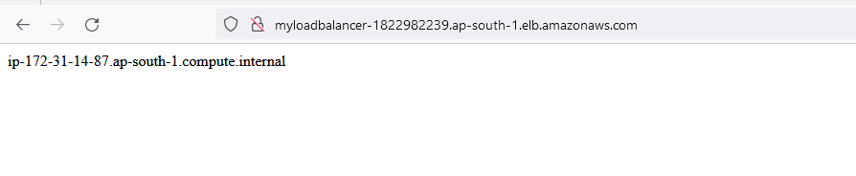

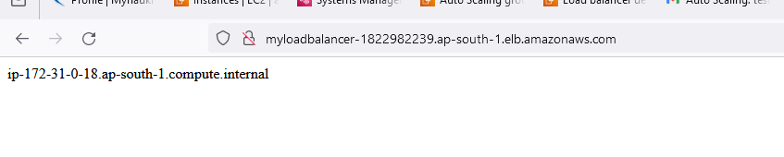

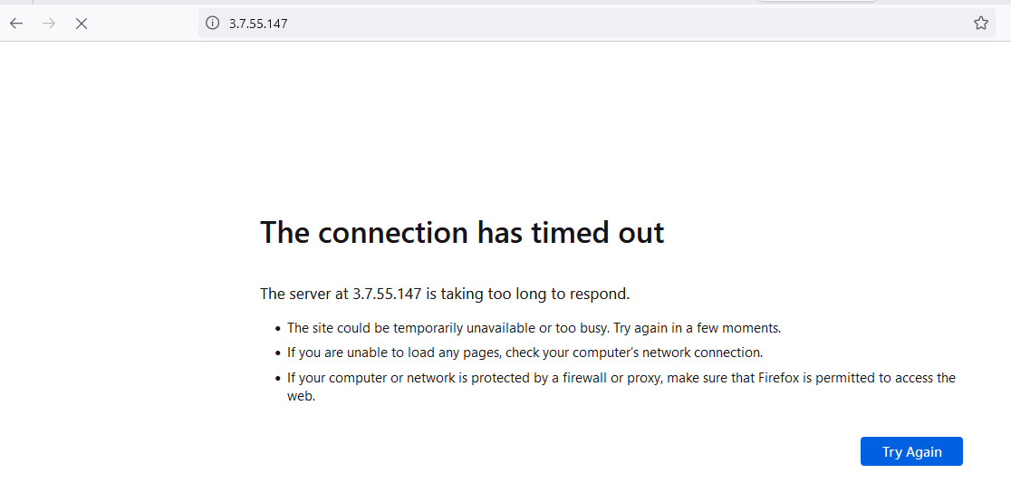

Instances auto scale out

